Illinois State Board of Education
Notes for Agricultural Education Grants for FY20
Incentive Funding Grants
- Step 1: Complete Incentive Funding App through Ag Ed website (X Factor List)
- Step 2: Prepare budget for your administrators once ISBE has provided dollar value for each point. Use the example budget detail below.
- Step 3: ISBE will send a list-serv message once the allocations are loaded and the application is ready in IWAS. Administrators will receive IWAS blast.
- Step 4: Share a PDF of your Incentive Funding Application from the IL Agricultural Education Website with your administrator to ensure it is loaded into the IWAS Incentive Budget Application.
- Step 5: Submit your application to ISBE. Once it has been officially submitted, your district can begin obligating funds.
- Reporting Requirements:
  - Quarterly reports: Due within 20 days of the end of each fiscal quarter. Be proactive and share your report with your admin so they can submit if you do not have access. Note: Higher risk districts might have to complete monthly reports
  - Final report/fourth quarter: upload Word or Excel document detailing all items purchased with grant funds, date of acquisition, learning goals accomplished, courses impacted (or FFA/SAE), and students impacted. There will be a template for this final report provided.
IFG Budget Detail:
- Please group your items according to use and function/object code. Each item does not need a separate line. See example below.
- Allows flexibility if prices change. As long as the money is under $50 and still used within the same budget cell and no new items are added, there is no need for amendment. If new items are added, they will need to approved through amendment.
  - Example: the MIG welder below went on sale for $385 ea, for a total savings of $20. The extra $20 was used to buy one extra pair of welding gloves (already approved). No amendment needed.
  - Example: The Refrigerator below was on sale for $901 for a total savings of $49. This $49 will be put toward more potting soil. This is under the $50 threshold mentioned above, however it will be moved from 1000/500 to 1000/400. This movement of funds will require an amendment.
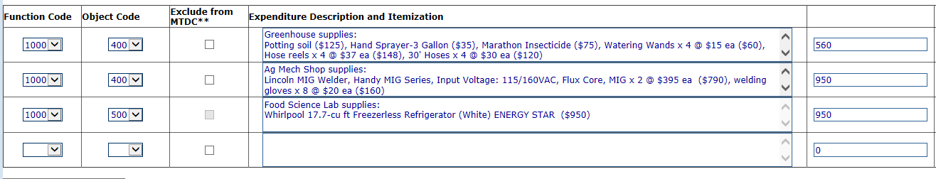

Three Circles IWAS Budget Application
- Step 1: Complete Incentive Initial Application in Spring 2020 (information will be forthcoming and a list serv message will be sent to notify of opening date).
- Step 2: Work with your administration to determine terms of payment for grant:
  - Questions to ask:
    - Base salary, 9 month without benefits, TRS and THIS covered by district
    - How will the district match funds be procured?
    - How will the district match be paid out?
    - How will the grant funds be paid out?
    - What types of hours will be acceptable/approvable by the district for the 400 total? Recommend that you provide an outline of hours and the SAE/FFA/Curricular break out prior to IWAS application submission (New for 2020-21, FY21 applications, this information will need to be provided in the grant application)
    - Is the 80% SAE/FFA and 20% Curricular breakout appropriate for the district? No more than 40% should be used for curricular.
  - Complete the District Match Workbook. You will be required to upload the Excel workbook found under the Three Circles (FFA & SAE) tab at: https://www.isbe.net/Pages/Agriculture-Education.aspx
- Step 3: ISBE will send a list-serv message once the allocations are loaded and the application is ready in IWAS. Administrators will receive IWAS blast.
  - Each teacher should have a minimum of 2 and maximum of 4 IWAS budget detail lines (See workbook IWAS Budget Detail tab for information)
  - Information must match the Excel workbook
- Step 4: Submit your application to ISBE, must be submitted no later than July 31 for a July 1 start date. Once it has been officially submitted, your district can begin obligating funds.
- Reporting Requirements:
  - Quarterly reports: Due within 20 days of the end of each fiscal quarter. Be proactive and share your hourly reports with your admin so they can submit if you do not have access. Note: Higher risk districts might have to complete monthly reports
  - Final report/fourth quarter: upload payment of funds confirmation letter on district letterhead (template on ISBE Ag Ed webpage) in addition to summary from AET of the 400 hours worked. Word or Excel document detailing learning goals accomplished, courses impacted (or FFA/SAE), and students impacted. There will be a template for this final report provided.

